Configure the Internet-Facing Application Load Balancer
1. Create the Web Target Group
- Go to Target Groups ➔ Create target group.
- Choose Instances as the target type.
- Name it (e.g., ALBTG-web-80).
- Select HTTP protocol and Port 80 (Nginx routes your Web tier).
- Select your project VPC.
- Configure Health Checks:
  - Protocol: HTTP
  - Path: Enter your frontend homepage path (e.g., /).
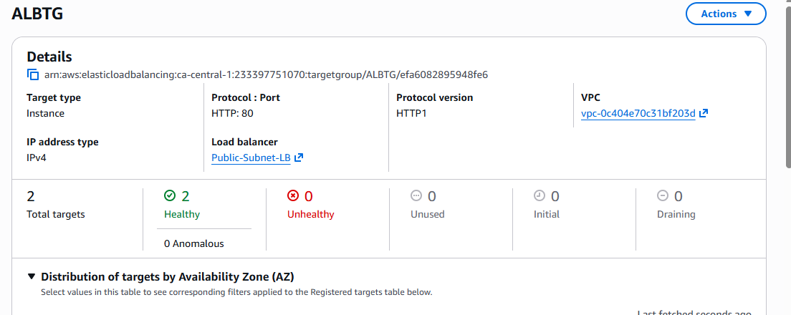
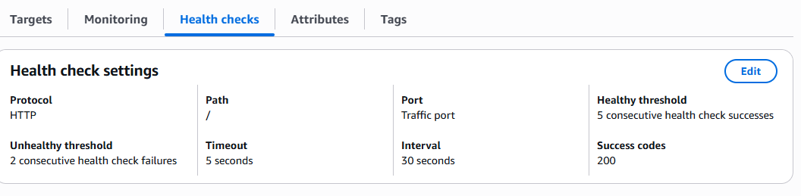
2. Register Web EC2 Instances
- Select your Public (or Private Web) EC2 instances.
- Enter Port 80 and click Include as pending below.
- Click Create target group.
- Both instance should be healthy
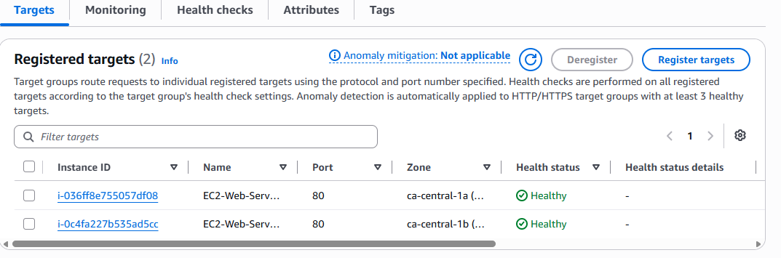
3. Create the Internet-Facing ALB
- Go to Load Balancers ➔ Create load balancer ➔ Application Load Balancer.
- Basic Configuration:
  - Name: e.g., Public-Subnet-LB
  - Scheme: Internet-facing (This provisions public IP addresses).
  - IP address type: IPv4
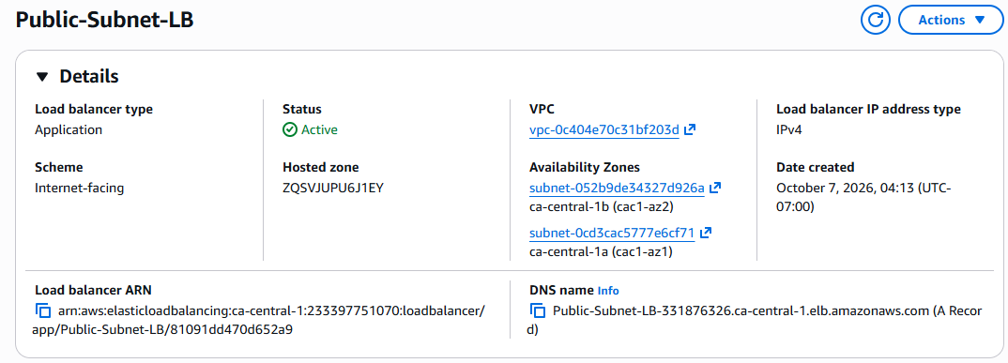
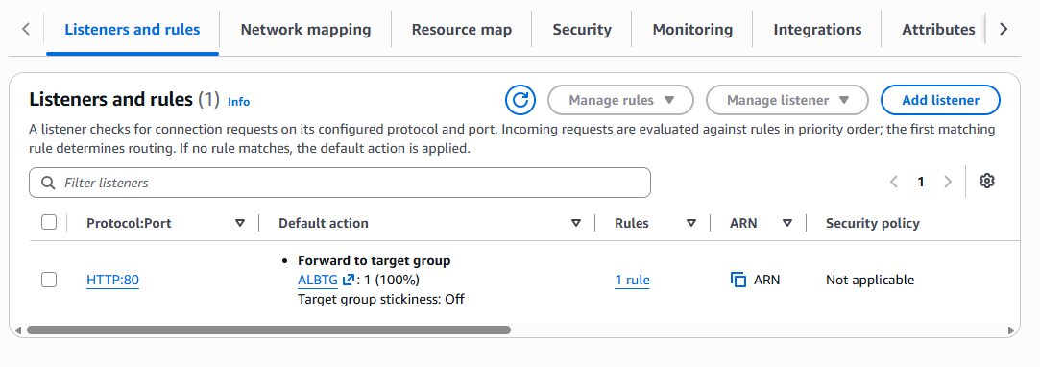
For verify
Go to http://Public-Subnet-LB-331876326.ca-central-1.elb.amazonaws.com
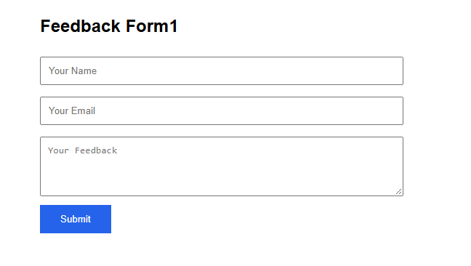

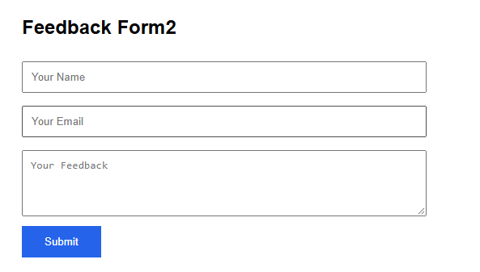
Conclusion:-Public Load Balancer Works properly

Configure Internal Application Load Balancer
1. Create the App Target Group
- Go to the EC2 Console ➔ Target Groups ➔ Create target group.
- Choose Instances as the target type.
- Name it (e.g., InternalprivateTG).
- Select HTTP protocol and Port 5000 (where your Flask app is running).
- Select your project VPC.
- Configure Health Checks:
  - Protocol: HTTP
  - Path: Enter your health check route (e.g., / ).
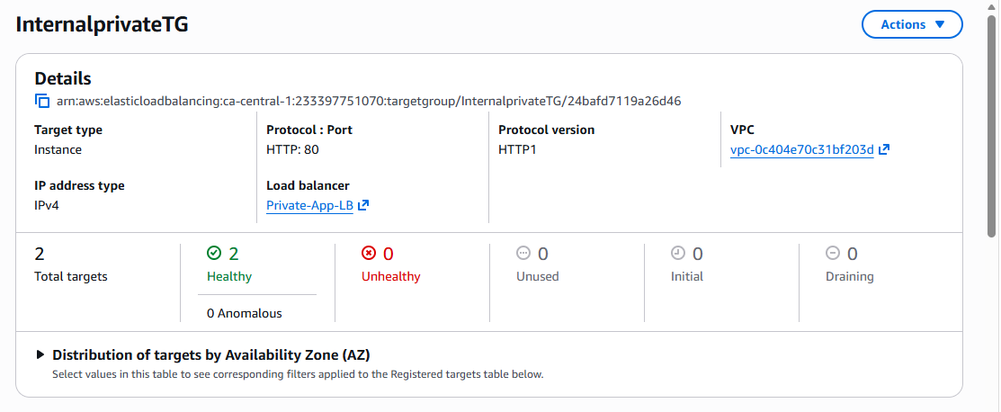
2. Register Flask EC2 Instances
- Click Next to move to the Register targets screen.
- Select your Private Application EC2 instances from the list.
- Enter Port 5000 and click Include as pending below.
- Review and click Create target group.
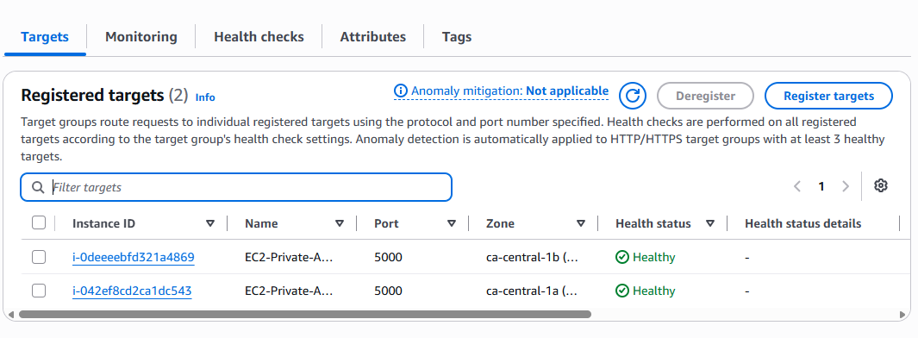
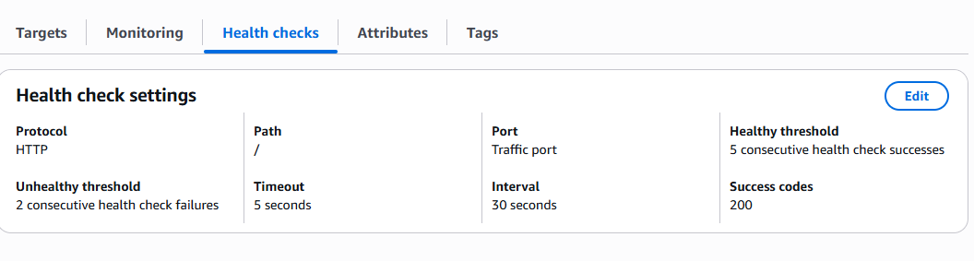
3. Create the Internal ALB
- Navigate to Load Balancers ➔ Create load balancer ➔ Select Application Load Balancer.
- Basic Configuration:
  - Name: e.g., Private-App-LB
  - Scheme: Internal (Crucial: This keeps it private within your VPC).
  - IP address type: IPv4
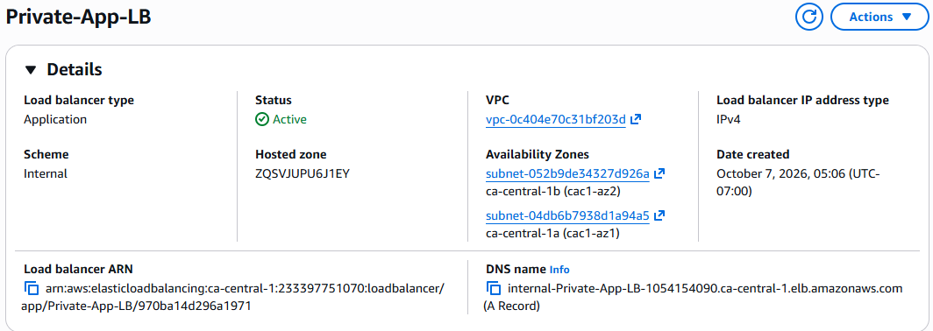

Also verify listener port
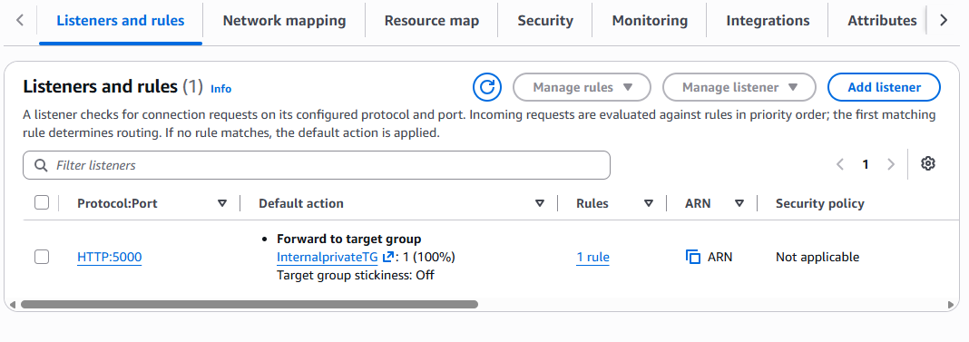
Finally verify the backend API via web tier instance

